. David Bohm 1917 – 1992
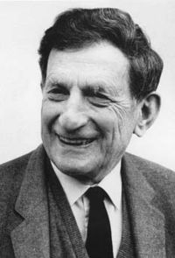

•Born Wilkes-Barre Pennsylvania
•At age 12 economic depression
•Science fiction fired his interest
•1942 nine months communist party.
•1950 arrested, bailed and tried House
Committee on un-American activities,
acquitted on all counts.
•Married Saral Wolfson Haifa 1956
•Unable to get work in USA
•1951 Brazil, 1955 Israel-Technion,
1957 Bristol, 1960 Birbeck College, U.K.

Introduction
The aim of the presentation is provide an introduction to David Bohm, to outline his vision and explain the practical consequences and possibilities arising from his work.
His life was dedicated to revealing wholeness – expressed in his work as a theoretical physicist of the highest order, a philosopher, neuropsychologist and social innovator.

Wholeness

His main concern was the possibility of a transformation of consciousness – individually and collectively and both his scientific and non-scientific work contributed to this enquiry. "Humans have sought individual enlightenment but we haven’t looked at what is involved in social enlightenment, becoming socially intelligent ".

Bohm (1980, p. 11) said: "The new form of insight can perhaps best be called Undivided Wholeness in Flowing Movement. This view implies that flow is, in some sense, prior to that of the ‘things’ that can be seen to form and dissolve in this flow". According to Bohm, a vivid image of this sense of analysis of the whole is afforded by vortex structures in a flowing stream. Such vortices can be relatively stable patterns within a continuous flow, but such an analysis does not imply that the flow patterns have any sharp division, or that they are literally separate and independently existent entities; rather, they are most fundamentally undivided. Thus, according to Bohm’s view, the whole is in continuous flux, and hence is referred to as the holomovement (movement of the whole).

There is a delicate empiricism that makes itself utterly identical with the object, thereby becoming true theory. But this enhancement of our mental powers belongs to a highly evolved age.

Goethe

The Greek root of the word ‘theory’ means to behold. So, becoming true theory is to truly behold, in other words what I describe as ‘right apprehension’.

An entirely different way of looking at the world? For example: Krishnamurti pointed to direct awareness of a universal ground, the same ground Bohm was trying to describe in his physics. Is this what Goethe, Blake and others were also aware of. In the above example, the reference to subtlety, empiricism and our unawareness is very Bohmian.

Bohm imagined our world as a three dimensional cross-section of a four-dimensional world and as he learnt mathematics he saw it as a tool that would enable him to show that what appeared as separate objects in 3D (time, space, matter) were, in 4D, aspects of a single whole, a 4D cosmos.

Not step by step enquiry but through the interconnections of various aspects to the whole. Never wrote down the formula before already sure of the result on qualitative grounds. Tried to avoid exhaustion caused by banging his head on insurmountable rock walls but ceaselessly feel out aspects of the problem, how things fit together, finding cracks and weak points. Humans through their minds exist in an information field. This is similar to what is happening in sub-atomic world.

Character & personality
Shy, withdrawn.
•Love of fantasy as a boy, and his rich imagination and urge to seek and experience the transcendent was a powerful motivation for his creative research.
•Love of nature
• Physically awkward.Lack of coordination, tried to overcome it by watching and imitating others,
•Crossing the stream and the realization of life as a flowing movement
•Brilliant yet modest. Totally free from guile and competitiveness – a secular saint.
•Subject to severe periods of depression in later life

His first book, Quantum Theory published in 1951, was well-received by Einstein, among others. However, Bohm became dissatisfied with the orthodox approach to quantum theory, which he had written about in that book, and began to develop his own approach (Bohm interpretation)— a non-local hidden variable deterministic theory whose predictions agree perfectly with the nondeterministic quantum theory. His work and the EPR argument became the major factor motivating John Bell's inequality, whose consequences are still being investigated.
Major controversy arose from the fact that although he wrote the text book on the contemporary version of quantum theory, i.e., the Copenhagen Interpretation with its associated sub-interpretations of quantum jumps and observer created reality, he proposed an alternative in which electrons are guided along paths by what he called quantum potential, (the Causal Interpretation. Also referred to as hidden variable theory). It was met not with rejection but silence.
His view on this is expressed in the following: "Classical physics provided a mirror that reflected only the objective structure of the human being who was the observer. There is no room in this scheme for his mental process which is thus regarded as separate or as a mere 'epiphenomenon' of the objective processes. ...
Through the mirror [of quantum physics] the observer sees 'himself' both physically and mentally in the larger setting of the universe as a whole. ... More broadly one could say that through the human being, the universe is making a mirror to observe itself." -- Bohm and Hiley, The Undivided Universe, pg. 389

Work: Bohm made a number of significant contributions to physics, particularly in the area of quantum mechanics and relativity theory.

- Plasma: A plasma functions in a collective way, oscillating as a whole. Yet it is built out of particles, each of which moves freely with its own individual movement. In a plasma, as in an ideal Marxist society, there is a subtle relationship between the free individual and the collective.

- Active information: A ship on automatic pilot proceeds under its own yet power guided by radar waves.

- Bohm-diffusion

- While still a post-graduate at Berkeley, he discovered the electron phenomenon now known as Bohm-diffusion .

- The Bohm interpretation of quantum mechanics, sometimes called the Causal interpretation, the Ontological interpretation or the de Broglie-Bohm theory, is an interpretation postulated by David Bohm in which the existence of a non-local universal wavefunction allows distant particles to interact instantaneously.
The interpretation generalizes Louis de Broglie's pilot wave theory from 1927, which posits that both wave and particle are real. The wave function 'guides' the motion of the particle, and evolves according to the Schrödinger equation. The interpretation assumes a single, nonsplitting universe (unlike the Everett many-worlds interpretation) and is deterministic (unlike the Copenhagen interpretation with its associated sub-interpretations of quantum jumps and observer created reality). It says the state of the universe evolves smoothly through time, without the collapsing of wavefunctions when a measurement occurs, as in the Copenhagen interpretation. However, it does this by assuming a number of hidden variables, namely the positions of all the particles in the universe, which, like probability amplitudes in other interpretations, can never be measured directly.
- Bohm’s paradigm is inherently antithetical to reductionism, in most forms, and accordingly can be regarded as a form of ontological holism. On this, Bohm noted of prevailing views among physicists: "the world is assumed to be constituted of a set of separately existent, indivisible and unchangeable 'elementary particles', which are the fundamental 'building blocks' of the entire universe … there seems to be an unshakable faith among physicists that either such particles, or some other kind yet to be discovered, will eventually make possible a complete and coherent explanation of everything" (Bohm, 1980, p. 173).

- In Bohm’s conception of order, then, primacy is given to the undivided whole, and the Implicate Order inherent within the whole, rather than to parts of the whole, such as particles, quantum states, and continua. For Bohm, the whole encompasses all things, structures, abstractions and processes, including processes that result in (relatively) stable structures as well as those that involve metamorphosis of structures or things. In this view, parts may be entities normally regarded as physical, such as atoms or sub-atomic particles, but they may also be abstract entities, such as quantum states. Whatever their nature and character, according to Bohm, these parts are considered in terms of the whole, and in such terms, they constitute relatively autonomous and independent "sub-totalities". The implication of the view is, therefore, that nothing is entirely separate or autonomous.

- …in relativity, movement is continuous, causally determinate and well defined, while in quantum mechanics it is discontinuous, not causally determinate and not well-defined. Each theory is committed to its own notions of essentially static and fragmentary modes of existence (relativity to that of separate events connectible by signals, and quantum mechanics to a well-defined quantum state). One thus sees that a new kind of theory is needed which drops these basic commitments and at most recovers some essential features of the older theories as abstract forms derived from a deeper reality in which what prevails is unbroken wholeness.

Partnership with Krishnamurti
In Krishnamurti’s teaching Bohm found a parallel expression of his own concern with wholeness: Krishnamurti’s view that the individual consciousness is a manifestation of the whole of human consciousness, that the observer is the observed and that thought is a material process. In a series of seven dialogues entitled The Transformation of Consciousness Bohm and Krishnamurti explore what is involved in de-coupling awareness from ego. At one point in the tapes Bohm summarizes the enquiry by saying “…the whole is the absence of the me”. Other dialogues between Krishnamurti and Bohm are recorded in two books Truth & Actuality and The Ending of Time

Implicate Order – a new model of reality

Consciousness not an epiphenomenon of material evolution. Nor is it a property of higher animals. It is woven implicitly into all matter. In the Bohmian universe matter and meaning continually affect each other. As in the body, so in the mind – mind affects body & vice versa. Quantum wholeness is primary – the explicate order secondary.

- No-thing – …what is implied by this proposal is that what we call empty space contains an immense background of energy, and that matter as we know it is a small, "quantized" wavelike excitation on top of this background, rather like a tiny ripple on a vast sea. In current physical theories, one avoids the explicit consideration of this background by calculating only the difference between the energy of empty space and that of space with matter in it. This difference is all that counts in the determination of the general properties of matter as they are presently accessible to observation. However, further developments in physics may make it possible to probe the above-described background in a more direct way. Moreover, even at present, this vast sea of energy may play a key part in the understanding of the cosmos as a whole.

- Indeed, if one applies the rules of quantum theory to the currently accepted general theory of relativity, one finds that the gravitational field is also constituted of such "wave-particle" modes, each having a minimum "zero-point" energy. As a result the gravitational field, and therefore the definition of what is to be meant by distance, cease to be completely defined. As we keep on adding excitations corresponding to shorter and shorter wavelengths to the gravitational field, we come to a certain length at which the measurement of space and time becomes totally undefinable. Beyond this, the whole notion of space and time as we know it would fade out, into something that is at present unspecifiable. So it would be reasonable to suppose, at least provisionally, that this is the shortest wavelength that should be considered as contributing to the "zero-point" energy of space. When this length is estimated it turns out to be about 10-33. This is much shorter than anything thus far probed in physical experiments (which have got down to about 10-17 cm or so). If one computes the amount of energy that would be in one cubic centimetre of space, with this shortest possible wavelength, it turns out to be very far beyond the total energy of all the matter in the known universe?

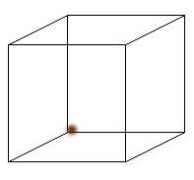

Necker & Cyber Cubes – Examples of enfoldment. Various interpretations embedded in the whole.

- The television analogy –Bohm also used the term unfoldment to characterise processes in which the Explicate Order becomes relevant (or "relevated"). Bohm likens unfoldment also to the decoding of a television signal to produce a sensible image on a screen. The signal, screen, and television electronics in this analogy represent the Implicate Order whilst the image produced represents the Explicate Order.

The two television analogy –

Bohm illustrates this higher-dimensional reality by showing the relationship of two televised images of a fish tank, where the fish are seen through two walls at right angles to one another. What is seen is that there is a certain "relationship between the images appearing on the two screens." We know, Bohm notes, that the two fish tank images are interacting actualities, but they are not two independently existent realities. "Rather, they refer to a single actuality, which is the common ground of both." For Bohm this single actuality is of higher dimensionality, because the television images are two-dimensional projections of a three-dimensional reality, which "holds these two-dimensional projections within it." These projections are only abstractions, but the "three-dimensional reality *is* neither of these--rather it is something else, something of a nature beyond both."

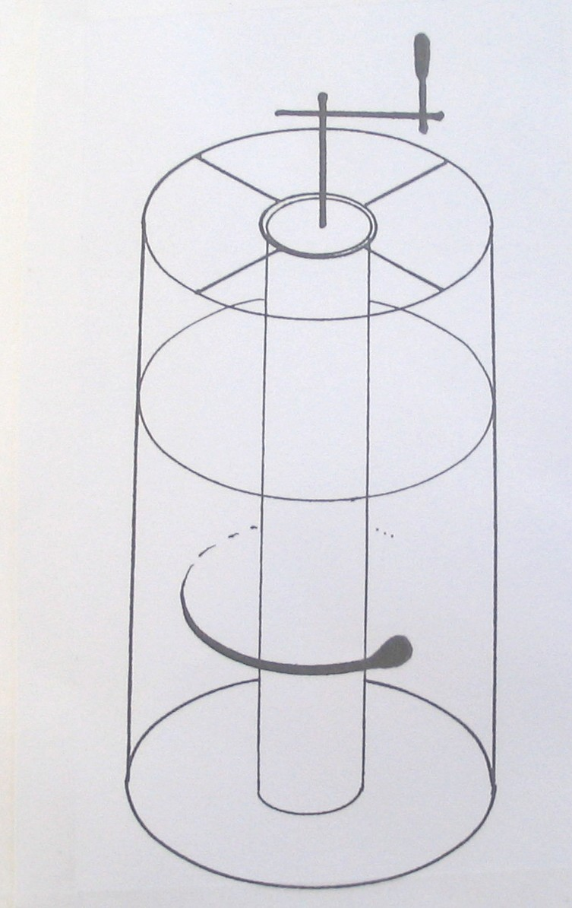
The Glycerine Experiment – He uses an interesting example in which an ink droplet can be introduced into a highly viscous substance (such as glycerine), and the substance rotated very slowly such that there is negligible diffusion of the substance. In this example, the droplet becomes a thread which, in turn, eventually becomes invisible. However, by rotating the substance in the reverse direction, the droplet can essentially reform. When it is invisible, according to Bohm, the order of the ink droplet as a pattern can be said to be implicate within the substance.
\

Hologram – Another analogy is the hologram. To make a hologram we split a laser beam into two pieces with a half-silvered mirror. One piece goes straight to a photographic plate, the other bounces off the object and then goes to the plate. In order to reconstruct the image of the object we shine a laser beam through the developed plate: the three-dimensional image appears. Note that in some sense the hologram on the plate is an interference pattern between the beam that has experienced the thing and the beam that experienced no-thing.

- One characteristic of a hologram is that down to at least a few grains of the silver in the plate, each piece of the plate contains the entire image. If we cut the plate in half we do not lose half the image; instead we lose resolution and the image becomes more fuzzy. Thus each piece of the plate contains the entire space of the object in an enfolded way; this is an analogy to the implicate order. When we reconstruct the image, we have unfolded the implicate order into an explicate one.
Using Bohm's terminology, the holographic film along with the light cast on it represent the Implicate Order while the hologram represents the Explicate Order. Holomovement would be the act of casting the light on the film to produce the hologram.

Meaning
……generally, we may say that energy enfolds matter and meaning, while matter enfolds energy and meaning. And the way we find out about matter and energy is by seeing what it means. Thus, meaning enfolds matter and energy, and through this mutual enfoldment, the whole notion obtains unity. Bohm The emphasis here, as always, is on the word ‘seeing’.

Ending of Time
The circle diagram shows, in anti-clockwise progression, an evolutionary perspective of human consciousness from Alpha to Omega. At the transition point from our ‘present’ location in the mental segment to the integral there arises a possibility of inversion; an awakening to a non-temporal awareness which includes the whole movement. In Gebser’s words: Origin is ever-present. It is not a beginning, since all beginning is linked with time. And the present is not just the "now," today, the moment or a unit of time. It is ever-originating, an achievement of full integration and continuous renewal. Anyone able to "concretize," i.e., to realize and effect the reality of origin and the present in their entirety, supersedes "beginning" and "end" and the mere here and now.

The diagram also attempts to show this inversion of consciousness, consciousness now experienced as ‘all-encompassing awareness’ (graphically represented above as the Integral embracing the lot) in which history arises, and not as an emanation of a particular cultural period. George points out that the Harding experiments provide the means for what Gebser refers to as ‘verition’ or concretization of the integral. Bringing into being , and the ‘waring’ which is how Gebser describes the necessary action. (NOWletter 104) This has interesting correspondence with Bohm's views of wholeness and the need to apprehend the totality from within rather than through an intellectual, objective breakthrough.

Consciousness
For Bohm consciousness "involves awareness, attention, perception, acts of understanding, and perhaps yet more." Further, Bohm parallels the activity of consciousness with that of the Implicate Order in general. Consciousness, Bohm notes, can be "described in terms of a series of moments." Basically, "one moment gives rise to the next, in which context that was previously implicate is now explicate while the previous explicate content has become implicate." Consciousness is an interchange; it is a feedback process that results in a growing accumulation of understanding.
Bohm believed that the individual who uses inner energy and intelligence can transform mankind. The collectivity of individuals have reached the "principle of the consciousness of mankind," but they have not quite the "energy to reach the whole, to put it all on fire." Continuing with this theme on the transformation of consciousness, Bohm goes on to suggest that an intense heightening of individuals who have shaken off the "pollution of the ages" (wrong world views that propagate ignorance), who come into close and trusting relationship with one another, can begin to generate the immense power needed to ignite the whole consciousness of the world. In the depths of the Implicate Order, there is a "consciousness, deep down--of the whole of mankind." http://noosphere.cc/bohm.html

Language – Rheomode
………….we know upon reflection that all manifest objects are in a state of constant flux and change. So there is really no such thing as a thing; all objects are dynamic processes rather than static forms. To put it crudely, one could say that nouns do not really exist, only verbs exist. A noun is just a "slow" verb; that is, it refers to a process that is progressing so slowly so as to appear static. For example, the paper on which this text is printed appears to have a stable existence, but we know that it is, at all times including this very moment, changing and evolving towards dust. Hence paper would more accurately be called papering--to emphasize that it is always and inevitably a dynamic process undergoing perpetual change. Bohm experimented with restructuring language in this dynamic mode, which he called the rheomode, in an effort to more accurately reflect in language the true dynamic nature of reality.” He regarded etymology (origin of words) as the archaeology of thought.

Soma Significance
Bohm introduced the word, 'soma-significance', to replace 'psychosomatic': a term which, he suggests, implies a dualism, two separate entities - mind and body -which interact. This, he proposes, introduces a split or fragmentation between the physical and the mental that does not properly correspond to the actual state of affairs.
In his approach, 'soma', which means body or matter, is connected with 'significance' or meaning. (i.e. the meaning of matter.) Meaning is given the key role, rather than mind or matter as distinct entities. The notion of soma-significance, then, provides a bridge between mind and matter. It relates, simply, to two aspects of one over-all field of reality, to be distinguished only for the purposes of thought.

Dialogue
The possible consequences of successful dialogue include:
proprioception of thought, seeing through assumptions and realization of thought as a system, awakening to
reality or first nature, shared meaning and culture shift in the direction implied by Bohm’s dream of
a transformation of consciousness both individually and collectively.

An Ethic of Enquiry

• An enquiry not a debate
• Questioning not asserting
• Allow speaker to finish
• Question assumptions – internal & external
• Suspend point of view
• Priority of ear over mouth
• Group interest before self-interest
• Process before content or result
• Not-knowing
• Avoid dogmatic quotes (optional)
• Don't forget to question all the above

My personal Response to Bohm
•Light. Light as fundamental, the interchangeability of light and meaning: to throw light on something means to access its meaning, enlightenment, etc.
•The reciprocal experience in viewing objects. (238 IP)
•The abandonment or total suspension in dialogue and in life – leading to impersonal fellowship
•Great clarity & the connection to Harding (225 IP)

•Returning creation to the creator, e.g., Sufis, Christian Mystics
•‘No-thing’ as fundamental – concretization of the spirit

•For Bohm there was a “total awareness” that lies beyond consciousness and is the field in which creativity operates.
•Realizing a change of meaning is a change of being
•Formalization of my conviction that meaning is fundamental
•A demonstration of true religion in the sense of ending separation and re-connecting with the wholeness of life.

Obituary for Malcolm Sagenkahn
In considering the relationship between the finite and the infinite, we are led to observe that the whole field of the finite is inherently limited, in that it has no independent existence. It has the appearance of independent existence, but that appearance is merely the result of an abstraction of our thought. We can see this dependent nature of the finite from the fact that every finite thing is transient.
Our ordinary view holds that the field of the finite is all that there is. But if the finite has no independent existence, it cannot be all that is. We are in this way led to propose that the true ground of all being is the infinite, the unlimited; and that the infinite includes and contains the finite. In this view, the finite, with its transient nature, can only be understood as held suspended, as it were, beyond time and space, within the infinite.
The field of the finite is all that we can see, hear, touch, remember, and describe. This field is basically that which is manifest, or tangible. The essential quality of the infinite, by contrast, is its subtlety, its intangibility. This quality is conveyed in the word spirit, whose root meaning is "wind, or breath." This suggests an invisible but pervasive energy, to which the manifest world of the finite responds. This energy, or spirit, infuses all living beings, and without it any organism must fall apart into its constituent elements. That which is truly alive in the living being is this energy of spirit, and this is never born and never dies. David Bohm

Acknowledgments
This presentation draws principally on three books:
Infinite Potential by F. David Peat
The Essential David Bohm edited by Lee Nichol
Thought as a System by David Bohm
Also
A summary of David Bohm's paper entitled 'Soma-significance: a new notion of the relationship between the physical and the mental’ by Donald Factor.
New Age Journal interview with John Briggs
And Various websites:

http://www.satanya.org - http://noosphere.cc/bohm.html - http://noosphere.cc/bohm.html - http://fusionanomaly.net/davidbohm.html - http://www.metafysica.nl/holism /implicate_order.html http://www.fdavidpeat.com/interviews/bohm.htm -http://www.upscale.utoronto.ca/GeneralInterest/Harrison/BellsTheorem/BellsTheorem.html - http://en.wikipedia.org/ - http://en.wikipedia.org/wiki/Implicate_and_Explicate_Order#Quantum_theory_and_relativity_theory

